2017

Anqi Pan, Cynthia Poon, Mithun Mitra Nomula, Pranita G Patra,

Yun-Hui Liu

Impact of BOPS on Sales and Returns

Project Report

**Introduction**

The company has three online channels. Channels 2 and 6 started buy-online-pick-in store (BOPS) strategy on August 1st, 2010 and channel 5998 started BOPS on September 27th, 2012. The company sells jewelry products such as bridal, solitaires, diamond fashion and specialized jewelry etc.

**Objective**

To assess the impact of buy online pickup in store (BOPS) strategy on sales and returns.

**Data**

BOPS transactions made between August 1st, 2010 and July 31st, 2013 in channel 2, 6 and 5988.

**Models**

Logit and probit model are used to analyze the effect of BOPS on return. There is no big difference between logit and probit model and the result should be identical. The reason we used both is just to make sure we are on the right track. In addition, we believe that the net purchase amount, income level, gender, age, online store number, categories, and seasonality might also affect whether the customers decide to return the product or not. Therefore, we will use those variables as the control variables in our model.

**Result**

1. Logit model

From the output of logit model, we concluded that with BOPS, the probability of return will increase 1.43%.

1. Probit model

From the output of logit model, we concluded that with BOPS, the probability of return will increase 1.53%.

We found that the results of the two models are identical, so we will calculate the economic effect using the result of logit model.

**Accuracy of Logit model**

The accuracy of using logit model to predict the effect of BOPS on return is 89.61%.

**Limitation**In-store and online only store data are needed to compare the overall effect of BOPS on return.

**Financial Impact**

By using the result of logit model, it indicates that there is 1.43% increase in return with BOPS. By estimation, 1% return incurs $17 millions cost. With 1.43% return, it will incur $24.31 millions cost to the company.

**Recommendation**

Although it shows that BOPS increase the return 1.43%, we need to look at the overall effect of BOPS on sales and returns on both online and in-store channels to determine whether BOPS are a right strategy for the company. However, the company can adjust the current return policy and evaluate the difference. Besides, more customers demographic and behavioral data such as shopping habits and reasons to return, and competitors data such as products availability are useful for company to analyze other factors which cause return.

**Theoretical claims for Impact of BOPS on Monthly Sales:**

1. The intuitive theory is that BOPS strategy introduced in 2011 will impact monthly sales positively. This is depicted in the graph below by the steeper slope after 2011.
2. However, the rising sales cannot be attributed to just one factor-BOPS. Several factors such as market or economic growth, competition, changing prices of precious metals could impact the sales. The growth due to these factors between the years 2011-2012 is captured by the channel 5998(without BOPS). Thus, to quantify the impact of BOPS on channel 2 and 6 we shall use channel 5998 as a control group. Comparing the two groups 2 & 6-the treatment group and channel 5998-control group gives us the impact of “only BOPS strategy” on online sales. This spike in monthly is depicted by “P” in the graph below.
3. The second claim or intuitive conclusion is that BOPS should have no impact on the Bridal segment of products.

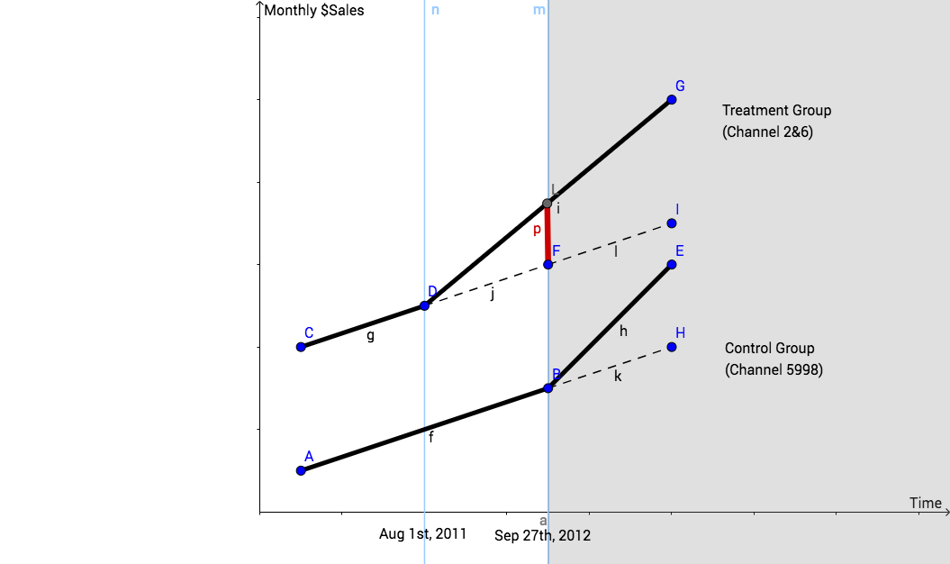

**Regressions Analysis:**

Model 1:

The difference in differences model has been used to capture the impact of BOPS. Interaction term of BOPS and treatment

*New variables*

1. Treatment =1 when channel=2 &6 else 0
2. Factor variables of months’ accounts for the seasonality
3. BOPS*Treatment -Captures the main impact and is our main impact
4. Monthly Sales-Sales are aggregated for each category and each month

**Call:**

**lm(formula = log_sales ~ month + bops_pol_change + treatment + bridal + treatment * bops_pol_change + year)**

Observation/Interpretation:

Impact of BOPS on sales is counter intuitive as it decreases the monthly online sales for channel 2 and 6 when compared to channel 5998 with no BOPS.

**Estimate Std. Error t value Pr(>|t|)**

**Bops_pol_change1:treatment1 -0.5629661 0.1630138 -3.4535 0.0005753 \*\*\***

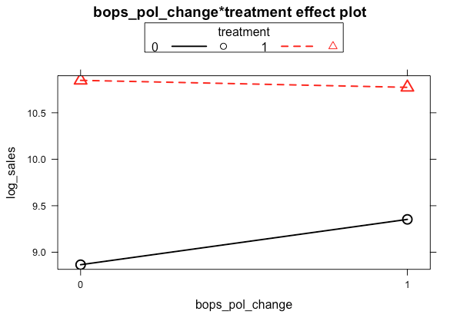

**Model 2:**

A three interaction term has been used to capture the impact of BOPS on BRIDAL categories of the treatment group.

**Call:**

**lm(formula = log_sales ~ month + bops_pol_change + treatment + bridal + treatment * bops_pol_change * bridal + year)**

**Observation**

1. The interaction term is insignificant due to heteroscedasticity.
2. Clustered standard errors are generated and it shows that the interaction term coefficient in negative.
3. Thus, BOPS have a negative impact on bridal category - it has less impact on monthly sales of bridal jewelry when compared to non-bridal categories.

**bops_pol_change1:treatment1:bridal1 -0.03074447 0.01330496 -2.3108 0.0210383 \***

**Conclusion/Explanation**

BOPS have a negative impact on the monthly sales of Bridal category products when compared to Non-Bridal (With clustered robust standard errors). This is almost impact with our assumption. This can be explained that customers are likely bridal accessories in store rather than online.

The Impact of what initially assumed was that BOPS strategy should increase the online sales, but through the data we can affirm that Overall sales of company are being increased not the online sales.

This is because, the customers who order through online have a leverage of returning the product or can find a better option than the online ordered product. Thus, there is a decline in sales through online channel but an increase in the in-store sales.

Although we do not have sufficient data to verify the impact on overall instore sales, the research support our above claim that decrease in the online sales is due to the channel shift by the customer.